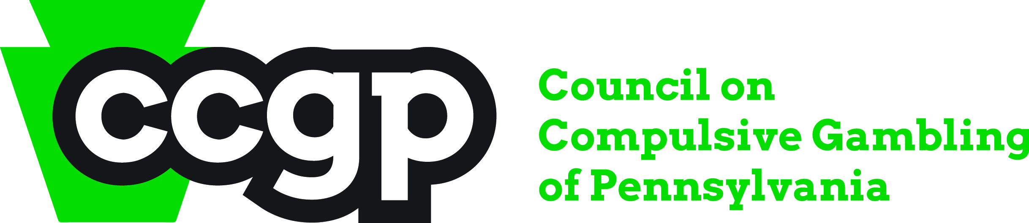

What is Gambling?
Take a moment to write about what gambling is/means to you. How would you define it? What images and/or words does the term ‘gambling’ create in your mind? Do you think gambling is good? Do you think gambling is bad?

